**Business Analysis Report**

**Ahmed K**

**August 2022**

**Table of Contents**

**Executive Summary** 3

**Literature Review** 4

**Variables** 4

**Expertise** 4

**Innovation** 5

**Perception of Success** 5

**Research Questions** 5

**Clearly Stated Questions** 6

**Data Preprocessing** 7

**Data Analysis** 8

**Exploratory Data Analysis** 8

**Correlation** 9

**Pivot Tables** 10

**Predictive Analysis** 11

**Discussion** 15

**Conclusion** 16

**References** 17

**Appendix A** 19

**Appendix B** 19

**Appendix C** 19

**Appendix D** 20

**Appendix F** 20

**Appendix G** 20

**Appendix H** 20

**Appendix I** 20

**Appendix J** 20

**Appendix K** 21

**Appendix L** 21

**Appendix M** 21

# **Executive Summary**

Odette consulting group (OCG) has conducted a comprehensive random survey to assess the business needs and requirements of its 200 clients. The analysis categorizes OCG’s clients by customer type, industry, firm size, and region. Furthermore, the specific approach uses exploratory and descriptive data analysis to investigate and summarize the various characteristics of the data set. Additionally, this information will allow OCG to improve efficiency in its client portfolio management, innovative project management, responsiveness, and expertise. OCG will also gain further insights into its overall client satisfaction, communication and implementation capabilities, the likelihood of being recommended to others and the potential for future partnerships.

Several analytic tools have been employed to further analyze the relationship between these factors and the reasoning behind the findings. Moreover, these tools and strategies allow OCG to capitalize on these insights as the firm better understands its relationship with its customers and the various descriptive characteristics they possess. These tools include box plots, pivot tables, scatter plots and a comprehensive correlation and regression analysis. Additionally, these tools have assisted in understanding the business requirements and needs of OCG.

# **Literature Review**

It is crucial to define 'Project Management Consulting' to ensure transparency and clear knowledge. It is defined as:

“An independent professional advisory service assists managers and organizations to achieve organizational purposes and objectives by solving management and business problems, identifying and seizing new opportunities, enhancing learning, and implementing changes.” (Cerruti et al., 2019)

Organizations turn to project management consulting expecting their performance to improve, find solutions to problems, enhance efficiency, and explore new ways of doing things in all sectors. Focusing on elements that could ensure the success of the consulting process; characteristics of the client organization, the competence of the consultant, and the consultation mode (specifically, adopting the proper methodology) are key variables of consulting efficacy (Jang and Lee, 1998; Chung et al., 2006).

Corrado et al. (2019) provided a literature review of scholarly research on management consulting. They discuss numerous variables impacting the success of project management consulting.

## **Expertise**

The education and experience of consultants, as well as their skills and values, significantly impact the consulting process's success. Furthermore, the extent to which consultants can leverage their personal and professional networks is critical (Mors, 2010), especially when combined with an international orientation and technology leveraging (Deprey et al., 2012). Given that consultants' skills are evaluated externally by clients, being multi-skilled, technically competent, and having excellent people skills are crucial (Simon and Kumar, 2001).

## **Innovation**

Managing innovation does not necessarily have to mean providing something new. Consulting-led management innovation is frequently highly standardized. Developing models for efficient knowledge systems is a significant focus of research on innovation as a driver of management consulting success (Werr and Stjernberg, 2003; Anand et al., 2007). According to Haas and Hansen (2005), competitive performance is determined by how much these organizations know and how they use what they know.

## **Perception of Success**

Several elements that influence consultants' perceptions of success include the intensity of collaboration, the consultant's expertise (Bronnenmayer et al., 2016), and client involvement in decision-making processes (Bennett and Smith, 2004). According to Haverila et al. (2011), consultant characteristics, customer focus, value, and enterprise considerations are broad themes driving client satisfaction. An empirical study of a leading global management consulting firm reveals significant differences in perceptions of reputation between and within stakeholder groups, with perceptions changing across dimensions and geographies: clients, external stakeholders, employees, and alumni all have different perceptions of corporate identity, and a strategy should be implemented to align those perceptions (Harvey et al., 2017).

# **Research Questions**

According to the literature review, we believe that project management consulting can assist managers in solving management and business problems by identifying opportunities and suggesting the best approach to implement the necessary changes. Furthermore, we analyze OCG’s list of 200 clients to find performance improvements in portfolio and project management, enhance efficiency and explore opportunities to improve the company’s relationship with its customers.

More importantly, the literature review suggests that consultant expertise and the client organization's consultation mode and characteristics will directly impact customer satisfaction. This can be incredibly valuable to business leaders as good client satisfaction positively impacts the perception of reputation between stakeholders. Therefore, exploring the factors contributing to client satisfaction is the focal point of a consulting firm's business needs and requirements analysis process. Reputation perception changes across different dimensions and geographics. Hence, analyzing OCG’s client list using various categories and their relationship with customer satisfaction provides valuable insights for the firm. These insights can help the firm sustain a competitive advantage in an industry filled with competent consultants with developed knowledge and expertise.

Additionally, managing projects utilizing innovation positively impacts competitive performance as businesses efficiently employ their business knowledge and expertise to develop successful strategies. Moreover, considering the literature review findings that highlight project management's importance to consulting business leaders, our research questions revolve around customer satisfaction, consultant expertise and the advantages of innovative strategies in project management. Furthermore, throughout the analysis process, we want to find what features or characteristics of the consulting firm have the highest positive impact on customer satisfaction. Additionally, we explore the relationship between consultant expertise, the utilization of innovative strategies and customer satisfaction.

**Clearly Stated Questions include:**

* What characteristics positively impact overall client satisfaction?
* Does the project management expertise of OCG’s consultants directly impact client satisfaction?
* Does the ability to manage projects innovatively directly impact client satisfaction?
* What other characteristics not realized through the literature review may play a significant role in client satisfaction?

# **Data Preprocessing**

After applying a descriptive statistics function to the original dataset, we find that there are 200 units of information in each metric. As such, it does not appear that there is any missing data that must be filed. In descriptive statistics, customer type, industry, firm size, and region may not be significant due to their categorical nature. They may be ignored since the values of 1, 2 and 3 are dummy variables and are representative of a categorical nature. The results of the descriptive analysis are shown in appendix A. The categories of customer type, industry type, firm size, and region are converted to 1s, 2s, and 3s for use in regression analysis. Also, customer ID is omitted from all calculations and analyses since this is an identifier, not data.

Box and whisker plots were generated for each metric to identify the minimum, maximum, and range. These plots are presented in appendix B. Outliers are identified as points that lie outside of the box and whisker plot, and the outliers have been removed and replaced with the metric’s respective means in the dataset. These adjustments are highlighted in appendix C ‘survey data no outliers.’ This minimizes the effect of the outlier on the data and further regression analyses. Lastly, something stood out in the descriptive statistics that needed to be addressed. The means of the metrics were as follows: portfolio management: 3.765, innovation: 5.365, responsiveness: 4.062, expertise: 5.250, consulting fee: 5.995, communication: 4.242, implementation: 3.816, satisfaction: 6.952, recommendation: 6.952, and partnership: 0.43. One would think that overall satisfaction is a metric that the data team would be trying to compute, given satisfaction in various specific metrics. It begs the question, is offering overall satisfaction in the questionnaire productive for this purpose? Should overall satisfaction not be representative of the satisfaction collection in individual metrics? If this is the case, why is overall satisfaction averaged at 6.952, but the only metric with a mean anywhere near 6.952 is recommendation. The average of the means of the individual metrics could indicate a calculated overall satisfaction and is computed as 4.93 – this seems more realistic as a means of overall satisfaction given the evidence or data.

# **Data Analysis**

## **Exploratory Data Analysis**

Looking at the descriptive analysis in appendix A, there is a slight positive skewness for portfolio management satisfaction (0.49). In this case, there is a tendency for data that lies below the mean. There is also a slight negative skewness in communication (-0.31) and implementation (-0.37). In these instances, there is a tendency of the data lies above the mean. Considering the metrics are based on a 10-point scale, except for partnership (which is 0 or 1), the averages are on the lower end – assuming 10 to be the best rating. A correlation grid was also constructed using the “data analytics” add-on in Excel. The results of the correlation are as follows - we will use a correlation of positive 0.7 as significant in terms of a correlation between predictors. For negative correlation, a value of negative 0.4 is used to determine a significant correlation between predictors.

Corrected descriptive statistics in appendix D are summarized. As previously mentioned, the means of the individual metrics appear to be low compared to overall satisfaction. For this reason, a new column is added to the ‘survey data no outliers’ worksheet, containing overall satisfaction as the average of the collective metrics of each client surveyed. The differences between the calculated satisfaction and the reported satisfaction are available for visual purposes only. For regression analysis, we will use the reported satisfaction.

### **Correlation**

The correlation results are calculated and presented in appendix E. Customer type refers to the length of the relationship between OCG and the client, with values of 1 (less than one year), 2 (1-5 years), and 3 (longer than 5 years). Using the original set of data, satisfaction is correlated with customer type (0.71), i.e., overall satisfaction with the services that OCG offers (0.71) improves positively as the relationship between the client and OCG grows. The longer the relationship runs, the more satisfied the clients are. After adjusting the survey data by removing the outliers and replacing them with respective averages, the correlation remained the same. There is also a strong correlation between how the client views OCG’s innovative capabilities and how well the client believes that OCG is implementing the creative solutions that are recommended for them (0.877). Those surveyed also found that those who were satisfied with the innovative capabilities of OCG were also satisfied with their ability to communicate those ideas to the client (0.740). After treatment of outliers, these values changed to 0.868 and 0.672.

After treating the data for outliers, this value became 0.868. Those that are satisfied were also likely to recommend OCG’s services to others, with a correlation of 0.762. After adjusting for outliers, this also remained the same. After adjustment, the correlation between satisfaction with services and the likelihood of partnering with OCG again became significant at 0.693.

There is also a slightly positive relationship between the longevity of the relationship and satisfaction with the following areas: implementation (0.57), recommendations (0.53), innovation (0.54), and partnership (0.51). There is a slightly negative relationship between the customer type and the consulting fee. (-0.42). In other words, the longer the relationship with the client, the less competitive the prices are relative to what is available in the industry. OCG appears to be charging their long-term clients more than they would newer clients. One explanation for this is the offering of lower prices to entice new clients to try out OCG’s services, then once the client depends on OCG for consultation, prices are increased to reflect the quality of recommendations.

The individuals who were satisfied with the portfolio management capabilities were also satisfied with the expertise of the management of the overall portfolio (0.79). After treatment of outliers, this correlation dropped to 0.67, which is still relatively significant.

### **Pivot Tables**

Pivot tables were created in excel and used to sort, organize, and summarize the survey data that has been adjusted for outliers. In appendix F, the data is organized based on the customer type (age of relationship). Then the averages of the individual metrics are outlined in the columns in the table. The most significant finding of this pivot table is that the average of “partnership” is 0.07. This means that the data is heavily skewed towards “no” when short term (less than 1 year) clients were asked whether they would consider a partnership again in the future. This is investigated further in the next pivot table (appendix G). In this table, we find that 92.65% of customers in type “1” (short term, less than 1 year) vote “no” (0) to whether they would consider a partnership with OCG in the future. This is a 7.35% rate of “yes”. OCG needs to investigate this and determine where the dissatisfaction lies. However, despite a 7.35% yes rate, the average satisfaction of short-term customers in the next table, appendix F, is 5.73. On average, the likelihood of a partnership with this group should be higher.

In the next pivot table, appendix H, the data is organized by the industry type, with 0 being non-IT and 1 being IT. The most significant finding from this pivot table is that customers in the IT industry are more satisfied with the competitiveness of pricing that OCG offers. This could be due to the fierceness of the technology industry in recent years. In appendix I, the pivot table organizes the data by the size of the firm, with 0 being 0-50 employees and 1 being 50 or more employees. The differences in satisfaction with OCG services in various categories are also displayed in this appendix. This table shows that in general, larger companies (50 or more employees) are more satisfied in all metrics are greater except communication. Lastly, appendix J displays a pivot table organizing the survey data by the region of the client, with 0 being Alberta and 1 being Ontario. This table summarizes the average satisfaction ratings in various metrics according to the region that the client operates in. It finds that clients based in Ontario are more satisfied with portfolio management, responsiveness, and consulting fees. However, it also shows that Albertian clients are more satisfied with the recommendations that are offered to them. as well as the overall experience working with OCG.

## **Predictive Analysis**

Data mining, predictive modelling, and machine learning are only a few statistical methods that are included in predictive analytics. These methods evaluate current and past data to anticipate future or otherwise unknowable occurrences. In this case, we want to predict and classify the ultimate customer client satisfaction towards OCG. Predictive models assist firms in attracting in, retaining, and expanding their most lucrative clients. This also includes enhancing operations. Predictive models are often used by businesses to forecast inventory and manage resources.

Predictive analytics is being used by organizations to find new possibilities and address challenging issues. The following are many of which that are not an exhaustive list of common uses of predictive analytics.

Detecting Fraud: Combining several analytics techniques helps increase pattern recognition and deter illicit activity. High-performance behavioural analytics monitors all network activity in real time to look for anomalies that might point to fraud, zero-day vulnerabilities, or advanced persistent attacks as cybersecurity concerns escalate.

Optimizing Marketing Campaigns: Predictive analytics are employed to forecast consumer behaviour or purchases and to encourage cross-selling opportunities. Predictive models assist firms in attracting in, keeping, and expanding their most lucrative clients.

Improving Operations: Predictive models are often used by businesses to forecast inventory and manage resources. To optimize occupancy and boost income, hotels try to anticipate the number of guests for any night. Organizations can work more effectively thanks to predictive analytics.

Reducing Risk: Credit ratings are a well-known use of predictive analytics that are used to determine a buyer's propensity to default on transactions. A predictive model's calculation of a person's creditworthiness yields a number known as a credit score. The usage of insurance claims and collections fall under the category of risk.

Predictive models build (or train) a model that may be applied to forecast values for various or new data sets using existing outcomes. Based on assessed relevance from a collection of input variables, modelling produces outcomes in the form of predictions that reflect a likelihood of the target variable (for example, client satisfaction).

Predictive models come in two different varieties. Models for classification foretell class membership. For instance, you may attempt to categorize someone's likelihood of leaving, inclination to respond to a solicitation, credit risk, etc. Typically, the model's output takes the form of a 0 or a 1, with 1 denoting the desired occurrence. Regression models forecast a number, such as the annual income a client will make or the number of months until a machine component fails.

One of the most often used statistical techniques is regression (both linear and logistic). Regression analysis determines how different variables are related. It identifies important patterns in huge data sets and is frequently used to assess the degree to which factors, such as price, impact the movement of an asset. It is designed for continuous data that may be assumed to follow a normal distribution. We wish to forecast a number using regression analysis, which is also known as the response or Y variable. One independent variable is utilized in linear regression to explain and/or forecast the result of Y. To predict the result, multiple regression employs two or more independent variables. A discrete variable's unknown variables are predicted using logistic regression using the values of other variables that are known. The answer variable can only take on a finite number of values because it is a categorical variable. A response variable in binary logistic regression only has

two values, 0 or 1. A response variable in multiple logistic regression may have one, two, or three levels, such as low, medium, and high.

Unfortunately, the logistic regression software was untapped on excel due to its inaccessibility. However, a regression analysis was conducted with the following data provided, to conduct a predictive analysis of overall client satisfaction. We partitioned our data using pivot tables to help with the creation of the regression analysis.

There are multiple linear regressions that can be generated to predict the future client satisfaction of OCG. For this case, it is necessary to identify the appropriate dependent variables. This includes 1. Overall client satisfaction, 2. Likelihood of recommending OCG to others and, 3. Potential future partnerships with OCG. These three dependent variables are the most appropriate to estimate the relationships between and the following independent variables 1. Length of relationship between a client and OCG (Customer Type) 2. Type of client industry (Industry Type), 3. Employee size (Firm Size), and 4. Region. For the sake of simplicity and space, a regression analysis only for the dependent variable of 'overall client satisfaction' will be conducted with the independent variables mentioned above.

We can see from the most appropriate regression analysis generated (Appendix K) that the adjusted R square strays away from 1. Meaning this model is not the greatest and that there are too many variables being used to determine the price of the house. We can use the correlation table to help make a more simpler regression analysis and determine a linear regression formula. Adjusted R-Squared tells us the usefulness of the model. This is a useful model because 55.2% of the variation in Y (Satisfaction), can be explained with the help of the variation in X. X is changing and therefore Y is changing. This is true for 55.2% of the time.

We can see that the significance of F is also below 0.05 which means this model may be significant. We consider it a statistically significant model. 95% of the time we are expected to receive that relationship is useful. We can create a formula using these numbers to help determine a predicted price of the house. The formula is Satisfaction = 4.485 + 1.083x1 + 0.588x2

If we plug in the necessary variables in each coefficient, we can determine a predicted satisfaction. If all the coefficient values were 0, this means the satisfaction of the clients would increase by 4.485 according to the positive intercept. We can also see that the p values for all these variables are below 0.05, which means they are all statistically significant. As they all have a 95% confidence interval.

The scatter plot (Appendix L) indicates that there is a positive relationship. The larger the firm size, the greater the client satisfaction. Upward slopping and corresponding increasing client satisfaction. Positive linear relationship. R2 tells you how many points fall on the regression line. 3.76% of the values fit the model.

The scatter plot (Appendix M) indicates that there is a positive relationship. The greater the length of relationship between a client and OCG the greater the client satisfaction. Upward slopping and corresponding increasing client satisfaction. Positive linear relationship. R2 tells you how many points fall on the regression line. 50.02% of the values fit the model.

# **Discussion**

Throughout the descriptive analysis process, customer type, industry type, firm size, and region categories are converted to 1s, 2s, and 3s for regression analysis. It is also important to highlight any omissions, which in this case, is Customer ID.

Using the original data set, satisfaction is correlated with customer type (0.71), i.e., overall satisfaction with the services that OCG offers (0.71) improves positively as the relationship between the client and OCG grows. We employed the box and whisker plot to display variation in the data set and highlighted the outliers in the various characteristics we analyzed. This showed:

There is a slightly negative relationship between the customer type and the consulting fee. (-0.42). This means that there is an opportunity for OCG to manipulate prices in their favour, considering clients and their competitive position in the market. The opportunity to offer lower prices could entice new clients to try out OCG’s services. Once the relationship is built and the client depends on OCG for consultation on a regular basis, prices are increased to reflect the quality of recommendations and the consistency and reliability that has been established through OCG’s proven results.

The individuals who were satisfied with the portfolio management capabilities were also satisfied with the expertise of the overall portfolio management (0.79). After treatment of outliers, this correlation dropped to 0.67, which is still relatively significant. This means that the firm can focus on improving their management capabilities and expertise as they are directly related and will always impact each other.

The data categorized under customer type (age of relationship) was highlighted when creating pivot tables. The most significant finding of this pivot table is that the average “partnership” is 0.07. This means that the data is heavily skewed towards “no” when short-term (less than one year) clients were asked whether they would consider a partnership again in the future. This means that there is some dissatisfaction with short-term clients, and OCG needs to investigate the reasons for this.

The last point is further explored, and we find that 92.65% of customers in type “1” (short term, less than one year) vote “no” (0) to whether they would consider a partnership with OCG in the future. This is a 7.35% rate of “yes.” OCG needs to investigate this and determine where the dissatisfaction lies. They need to look at why short-term customers are so reluctant to consider a partnership with OCG in the future and identify any fundamental or service issues that arise when dealing with these clients compared to when they deal with longer-term customers.

# **Conclusion**

The 200-client comprehensive random survey that Odette consulting group (OCG) has conducted has positive implications in the case. The opportunity to offer lower prices could entice new clients to try out OCG’s services. One of the most often used statistical techniques is regression, which was used in this data collection. Data mining, predictive modelling, and machine learning are only a few statistical methods that are included in predictive analytics. We believe that project management consulting can assist managers in solving management and business problems by identifying opportunities and suggesting the best approach to implement the necessary changes. This has been clearly displayed through the discussion in this data collection.

# **References**

Anand, N., Gardner, H.K. and Morris, T. (2007), “Knowledge-based innovation: emergence and embedding of new practice areas in management consulting firms”, Academy of Management Journal, Vol. 50 No. 2, pp. 406-428.

Bennett, R.J. and Smith, C. (2004), “The selection and control of management consultants by small business clients”, International Small Business Journal: Researching Entrepreneurship, Vol. 22 No. 5, pp. 435-462.

Bronnenmayer, M., Wirtz, B.W. and Göttel, V. (2016), “Determinants of perceived success in management consulting: an empirical investigation from the consultant perspective”, Management Research Review, Vol. 39 No. 6, pp. 706-738.

Chung, Q.B., Luo, W. and Wagner, W.P. (2006), “Strategic alliance of small firms in knowledge industries: a management consulting perspective”, Business Process Management Journal, Vol. 12 No. 2, pp. 206-233.

Cerruti, C., Tavoletti, E., & Grieco, C. (2019). Management consulting: A review of fifty years of scholarly research. *Management Research Review*, *42*(8), 902–925. <https://doi.org/10.1108/mrr-03-2018-0100>

Deprey, B., Lloyd-Reason, L. and Ibeh, K.I. (2012), “The internationalization of small- and medium-sized management consultancies: an exploratory study of key facilitating factors”, Service Industries Journal, Vol. 32 No. 10, pp. 1609-1621

Haas, M.R. and Hansen, M.T. (2005), “When using knowledge can hurt performance: the value of organizational capabilities in a management consulting company”, Strategic Management Journal, Vol. 26 No. 1, pp. 1-24.

Harvey, W.S., Tourky, M., Knight, E. and Kitchen, P. (2017), “Lens or prism? How organizations sustain multiple and competing reputations”, European Journal of Marketing, Vol. 51 No. 4, pp. 821-844.

Haverila, M., Bateman, E.R. and Naumann, E.R. (2011), “The drivers of customer satisfaction in strategic consulting engagements: a global study”, Management Decision, Vol. 49 No. 8, pp. 1354-1370.

Jang, Y. and Lee, J. (1998), “Factors influencing the success of management consulting projects”, International Journal of Project Management, Vol. 16 No. 2, pp. 67-72.

Kumar, V. and Simon, A. (2000), “Strategic capabilities which lead to management consulting success in Australia”, Management Decision, Vol. 38 No. 1, pp. 24-35.

Mors, M.L. (2010), “Innovation in a global consulting firm: when the problem is too much diversity”, Strategic Management Journal, Vol. 31 No. 8, pp. 841-872.

Werr, A. and Stjernberg, T. (2003), “Exploring management consulting firms as knowledge systems”, Organization Studies, Vol. 24 No. 6, pp. 881-908.

# **Appendix A**

# **Appendix B**

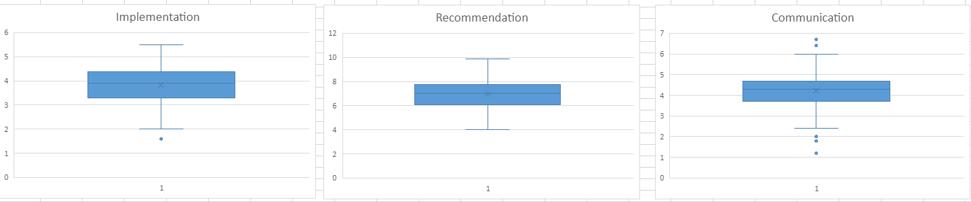  
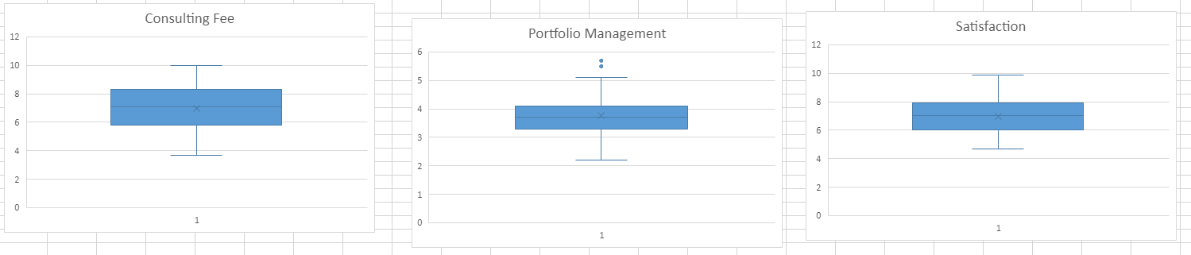  
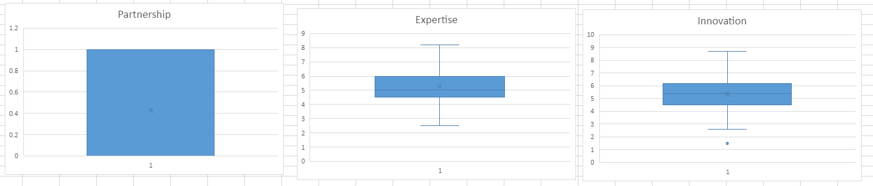

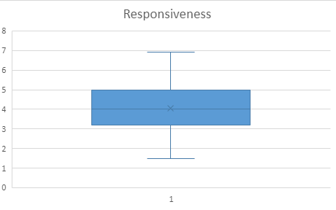

**Appendix C**  
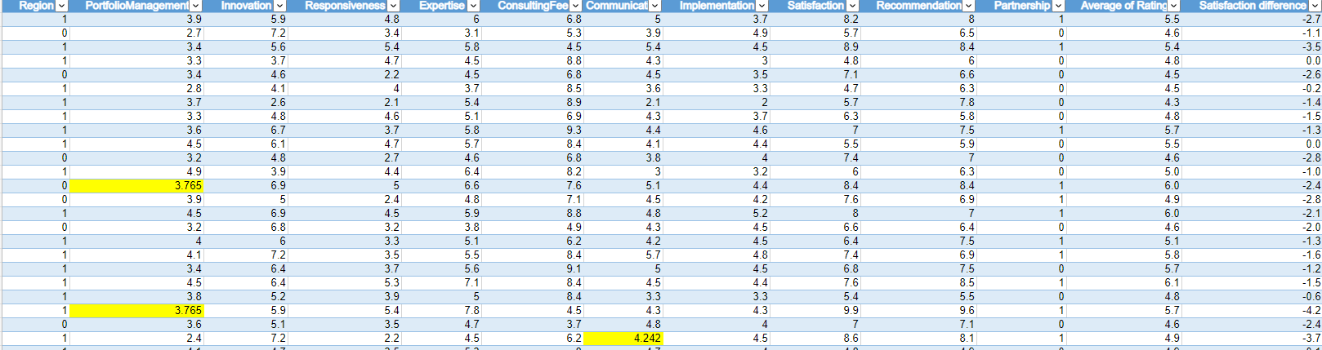

# **Appendix D**

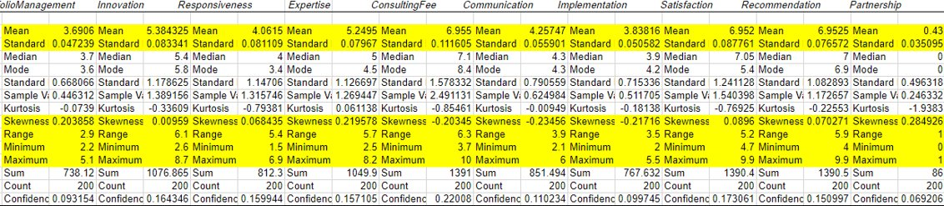

**Appendix E**  
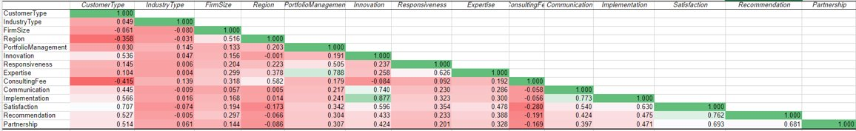

**Appendix F**  


**Appendix G**  
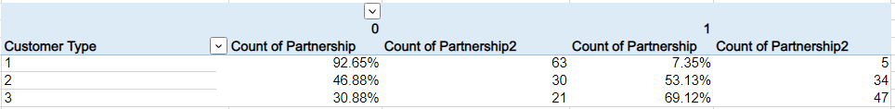

**Appendix H**   


# **Appendix I**

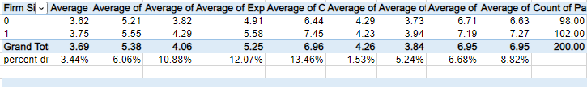

# **Appendix J**



# **Appendix K**

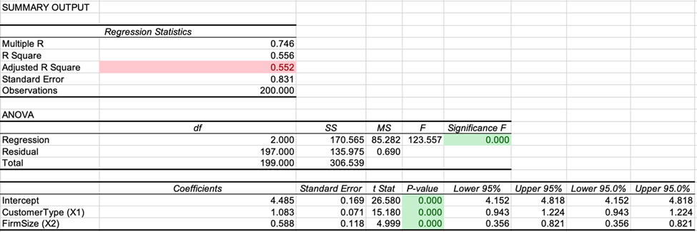

# **Appendix L**

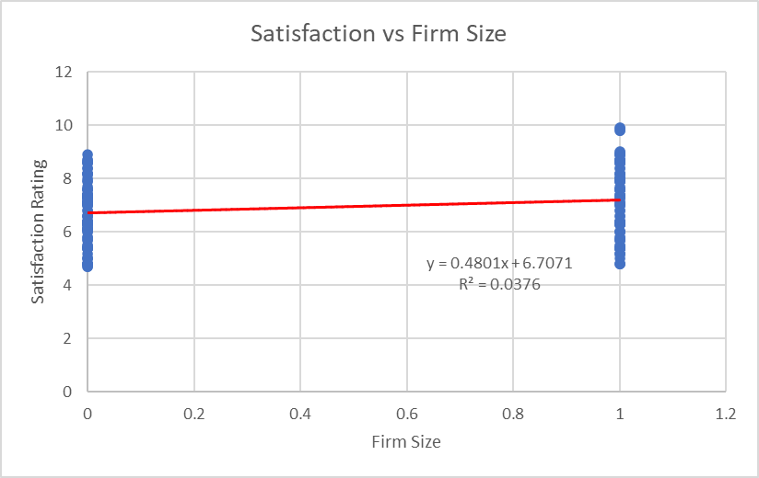

# **Appendix M**

